MISCELLANY MODELS

Item Reference – RS 02
Highland Railway – Early Pattern Lookout for Dia 38 Brake Van
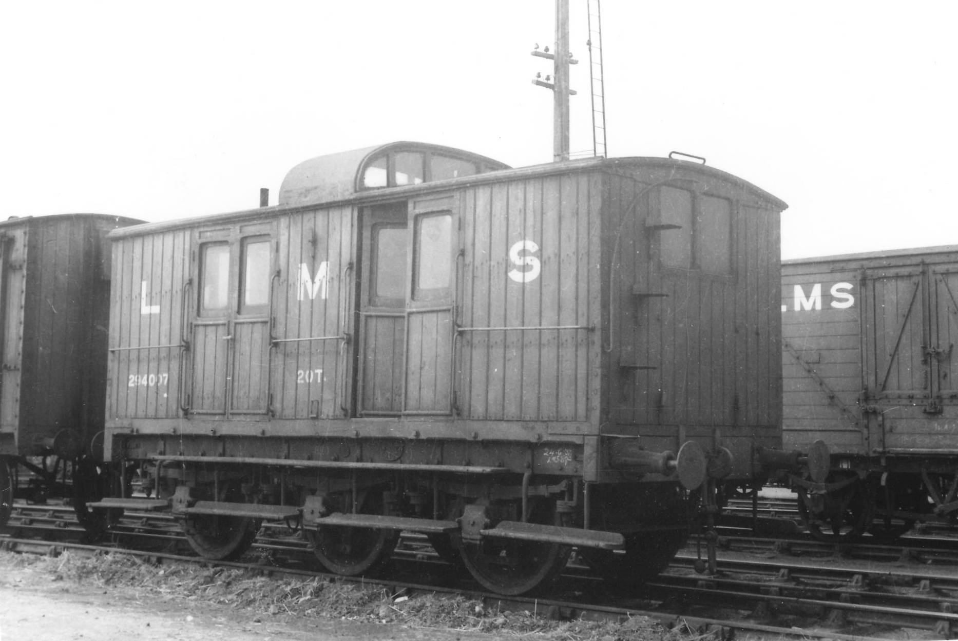
© Bruce Ellis, with permission.
Prototype
The Highland’s fourth phase of goods brake vans, the type D as they were initially known and then diagram 38 (LMS diagram 12), were arguably one of the signature features of the company. Construction commenced in 1908 and continued until 1918; initially on wooden underframes but latterly on steel underframes. It seems likely that these lasted into the second war and maybe beyond. The exact number built is not known, certainly discrete orders or numbers for 25 have been identified and there are likely to have been more.

They were shorter versions of the Type B brake vans and were fitted double doors to allow them to be used for parcels or items too small to make up a wagon load. However, it was their roof top birdcage type lookout that made them so characteristic; incorporated to allow the guard to keep a ready lookout on the sinuous and twisting lines of the Highland’s system without having to repeatedly crossing from side to side of the vehicle.

As originally built these lookouts formed by a single slot to the centre of the roof and were fully glazed to the front and back. In use guards complained that they caught their heads on the lip of the roof as they climbed in. To overcome this, many of the vans were rebuilt to include ramped approaches to the centre of the lookout were incorporated, a feature incorporated in later production runs at building.

The original vans were built with vertical matchboarding with the perimeter of each panel covered with beading. It was found that this beading captured water leading to premature rotting and over the life of the vans, when panels were repaired or rebuilt, the beading was omitted – something that happened to different degrees on different vehicles. Later orders of the vans were built without the beading at the outset.

Initially wheels were believed to be all spoked but some had been converted to disk wheels by the end of their lives. A variety of buffers can be seen in the available pictures, some at the time of building and others during the life of the vans.

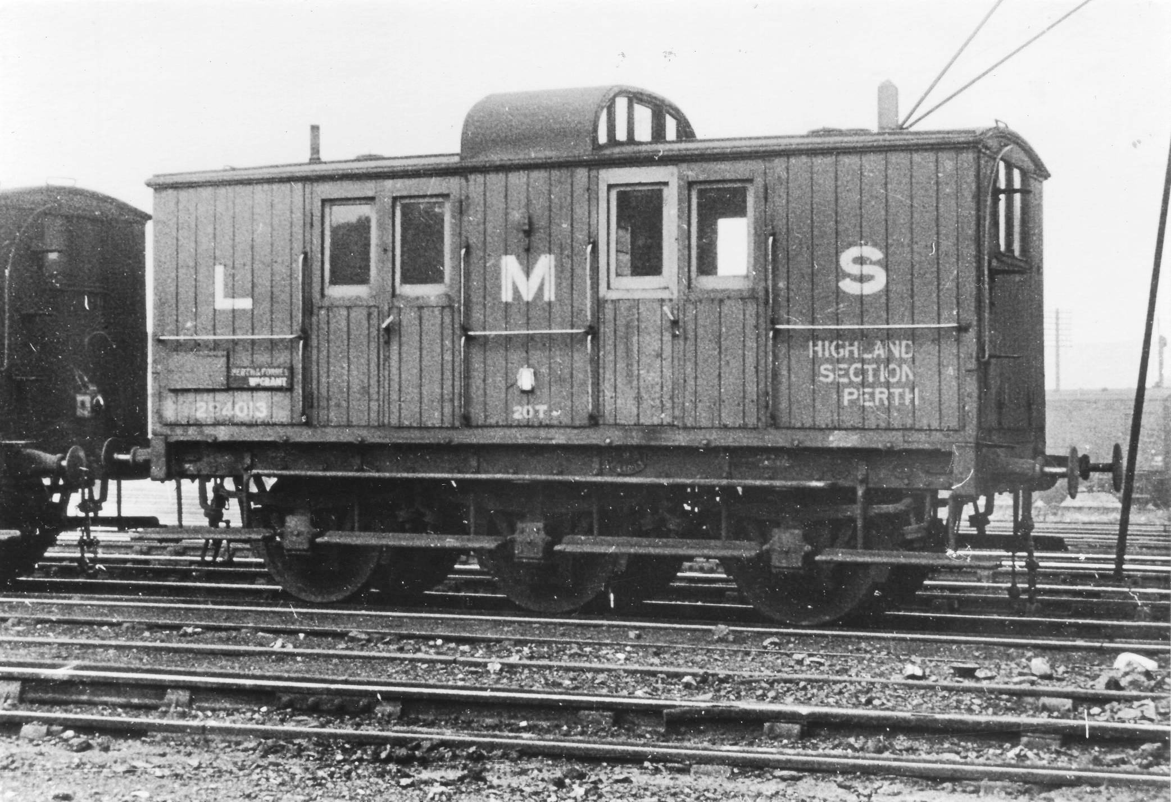
© Bill Steel, with permission
Components
A Lookout sides (2 no)
B Lookout Roof

Required to Complete
This product is conceived to modify the Microrail dia 38 Brake Van (also known as the type D van). This was available at various times from Mircorail and Alan Gibson and is sometimes available as a special order item from David Geen - http://davidgeen.co.uk/index.html.

Instructions
General
- Please read separate generic instructions on cutting, shaping and soldering etched brass kits.
Microrail Roof
- The etching for the roof included in the Microrail kit is etched on the bulk of its top to form the rainstrips; as such it is very thin and flimsy. Thus, prior to building the lookout it pays to laminate this onto a second sheet of 8 or 10 thou brass. This should be done after both pieces have been rolled to the appropriate curve and it pays to use a fairly high melt solder –s lots of heat is required!
- The Mircrorail roof is a tiny bit short for the body and thus make the laminate about 1mm too long at either end. Laminate a second strip on top of this at each end to match the thickness of the Microrail roof. Finish this such that the top surface has been dressed to the same height as the Mircrorail roof, but do not worry at this stage to get the length correct.
- The Microrail roof incorporates two slots for the sides of the lookout and the replacement sides (parts A) should be offered up to these. It will be necessary to reduce the tab on the replacement sides a touch to ensure that they properly bed into place. Prior to soldering them in place, drill four holes close to the corners of opening in the birdcage lookout with a 1mm bit.
- It is best to fit the roof in place now, prior to the fitting of the birdcage. It is only after it is fixed that the it should be shorted to suit the length of the body. It should project about ½ mm at each end.
Birdcage Lookout
- The birdcage sides can now be soldered into place – the slots in the Microrail roof match those provided on the birdcage sides. Once it is secure, the internal cut out formed with a piercing saw and files to then open it out to the full size. Prototypically it should go to almost the full width of the roof but it is better to leave 1-2mm at either side on the model, simply to give it some strength.
- The roof the birdcage has been etched with a rain strip to either side – as is visible in the picture at the head of these instructions. As a result, it too is rather thin and it pays to increase its thickness in the same manner as noted above. Alternatively, this rain strip did not seem to be universal as the second picture does not have it. If you are going to omit the rain strip, it is probably easier to replace the part with sheet brass cut to side.
- The roof needs to be rolled to shape as before, but this is rather more difficult because of the multiple curves to this. Do the more shallow curve first and then form the sharper one by folding the ends over a piece of rod (I used some 15mm dia brass tube). The birdcage roof should be very slightly narrower than the main roof, so that main roof cant rail runs through (see the pictures).
- The roof provided in the kit is a tad too wide to enable it to be filed back to a neat fit. Solder it in place first, before filing it back.

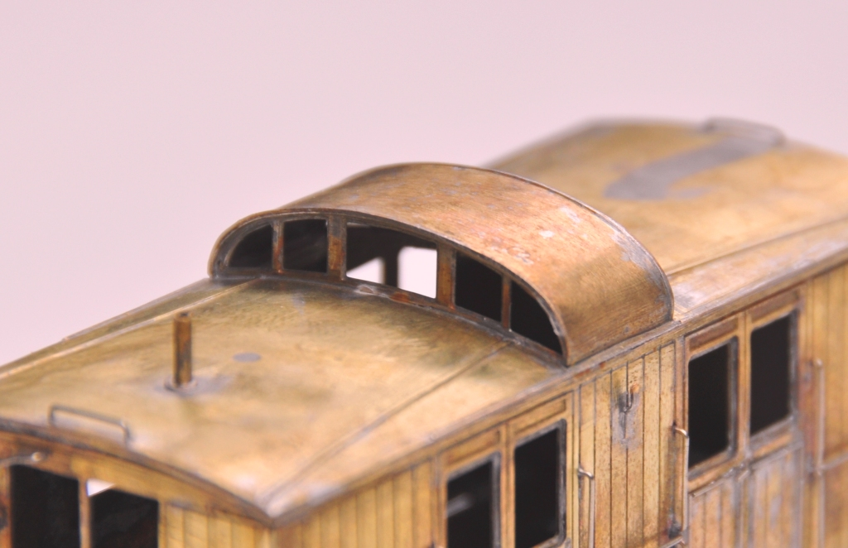

Other Modifications to the Microrail Kit
- There are a number of other modifications that are (or might be, there is variances in the prototype so a number of small details were different between vehicles) required. Here is a list of possible modifications you might want to consider:
- The footsteps were not always continuous; these were probably cut back and/or modified over the life of the vehicle though.
- Buffers were not consistent and a number of variants seemed to have been used.
- End straps between the headstocks and the body are visible in the top photograph.
- Sometimes the lamp tops were filled in, possibly because electric light was used?
- The cover beads were apparent in a number of the vehicles at original construction; whilst this tended to be deleted the top photograph still shows this on the doors;
- Various chalk boards seemed to gave been used on the sides of the vehicles.
- Lettering differences existed, even within a similar era.
- Sometimes screw link couplings replaced the original three links.
- Some had spoked wheels and others discs; probably changing through their lives.

